

March 27, 2024

The Honorable Jack Reed

U.S. District Courthouse

One Exchange Terrace

Suite 408

Providence, RI 02903-1744

Dear Senator Reed,

We are honored to write to you in support of the civics programming provided by Rhode Island Secretary of State Gregg Amore. As a former educator, Secretary Amore knows the importance of utilizing programs to engage and inspire our youth. He has made civic education and engagement a leading initiative in his administration.

As former social studies teachers ourselves, we know there is a need for more robust and enriching educational opportunities around social studies, government, and history for school-aged children. That is why we are whole-heartedly supporting Secretary Amore’s initiatives, specifically the Rhode Island Civic Leadership Summit.

The RI Civic Leadership Summit is an opportunity for students to not only gain requisite insight into the functions of government, but also spark curiosity and purpose around civic life. All students in the Ocean State deserve a high-quality civic education and it should include opportunities for them to advance their knowledge in history, law, culture, and the democratic process.

Providing hands-on civic learning opportunities, like with the RI Civic Leadership Summit, can be a transformational experience for young people – we know because we are both alumnae of Project In-Site, the program from which the Civic Leadership Summit derives. Programs such as these ensure we continue the interest and engagement in our “lively experiment” for years to come.

We strongly urge you to support Secretary Amore’s dynamic civics programming because an engaged and inspired citizenry is critical to democratic participation and more vibrant communities.

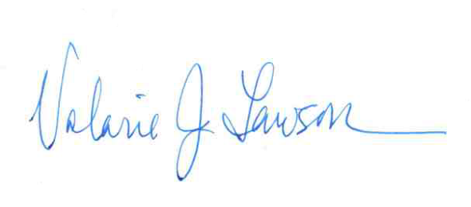

Very truly yours,

Valarie J. Lawson Mary K. Barden

President Executive Director

NEA Rhode Island NEA Rhode Island