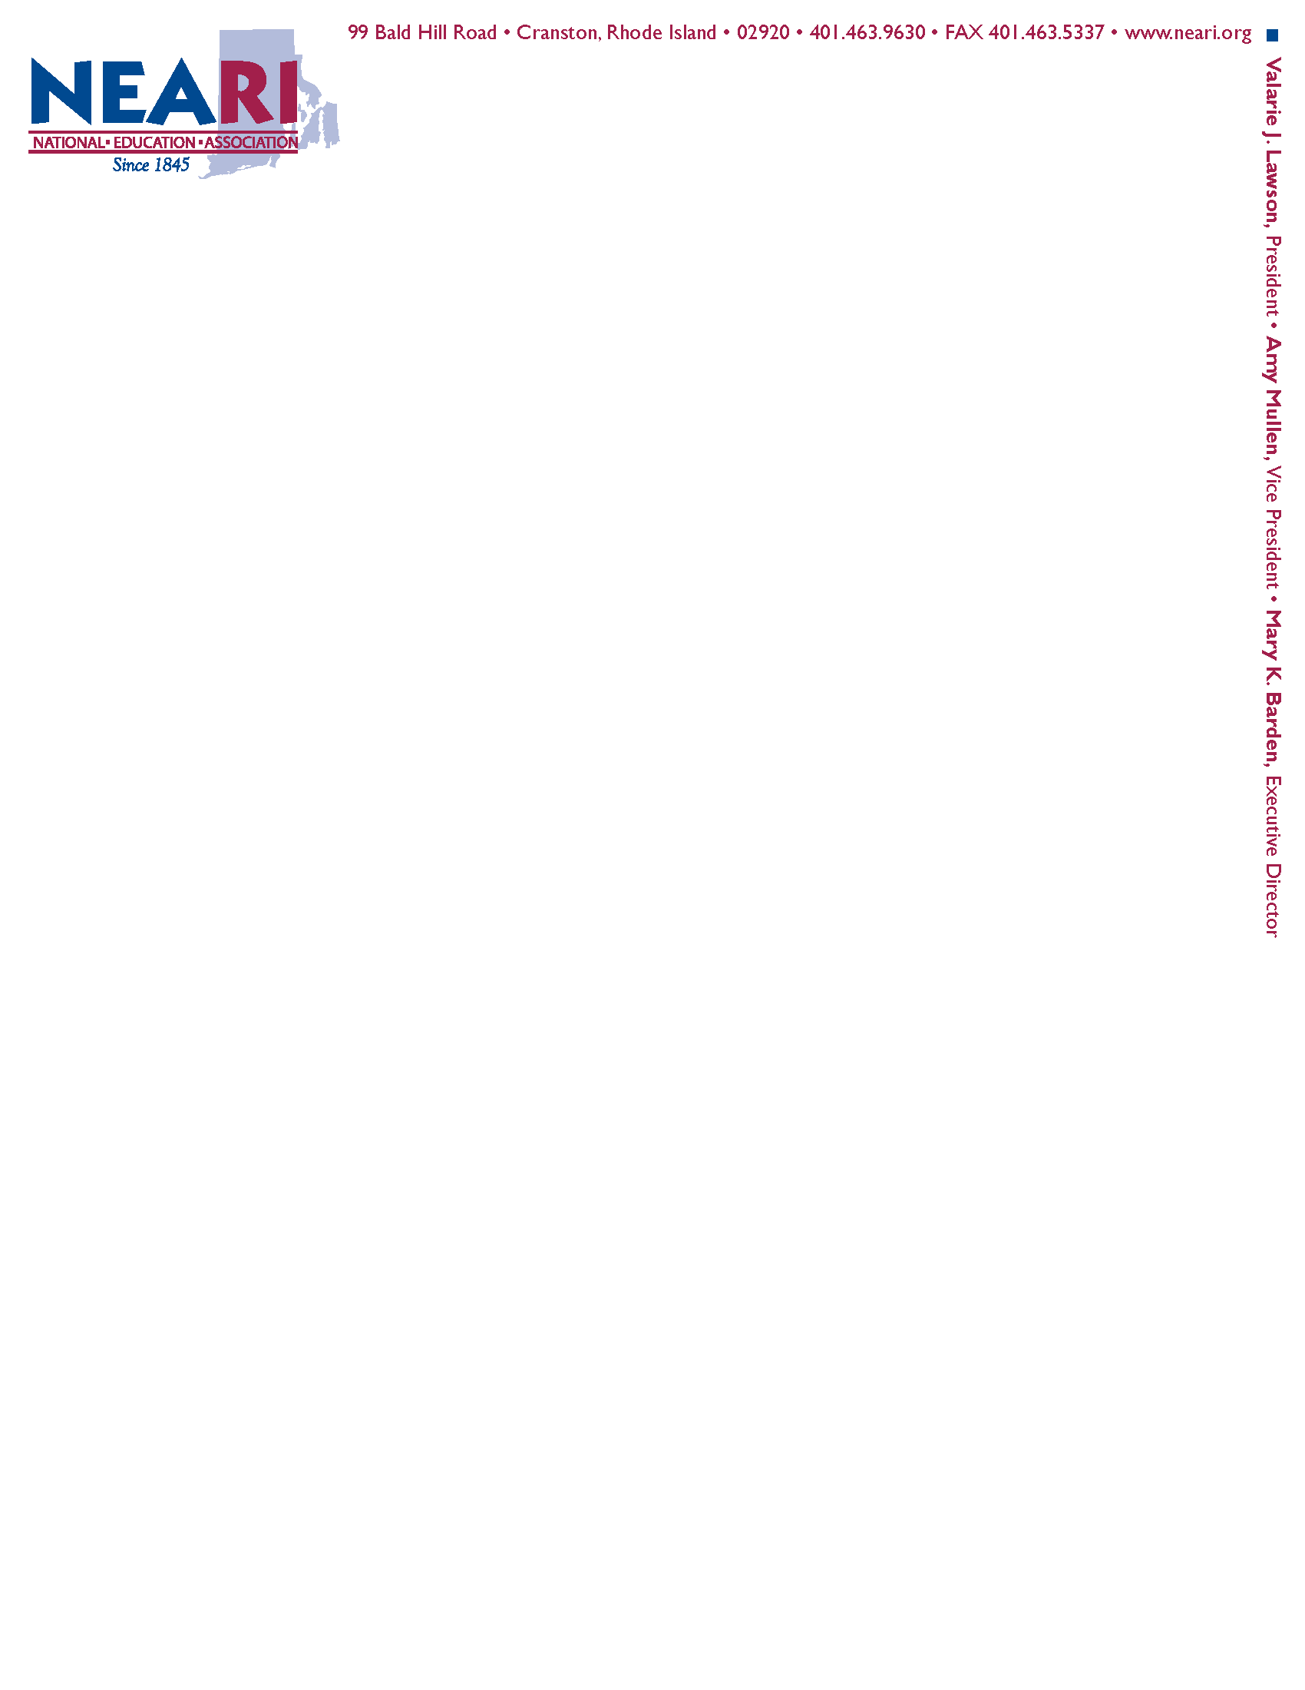

October 10, 2024

Council on Elementary and Secondary Education

Rhode Island Department of Education

255 Westminster St.

Providence, RI 02903

Via Email

Dear Members of the Council on Elementary and Secondary Education,

The National Education Association Rhode Island (NEARI) is writing in opposition to the proposed Rhode Island Cultural Academy Charter School.

Investments should be made in ***all*** district schools for real world and project-based experiences. These experiences should not be limited to one school. All students and teachers should have the opportunity, time, funding and resources to partner with cultural institutions and museums. Those partnerships should be widespread and supported by both state and local district funding and not limited to a select few who attend one school.

In fact, at one time, many schools and classrooms did expand student learning beyond the traditional classroom partnering with local and state cultural institutions. However, with the continued emphasis on high stakes standardized tests, real world and project-based experiences have been replaced by lessons that teach to the test.

In addition, arts and cultural programming are the first to be eliminated in district schools when there are budget constraints. This is coupled with the fact that many districts canceled field trips in 2021 after RIDE regulations were interpreted that districts couldn’t raise money to fund field trips. Although legislation was clarified to allow districts to budget for field trips, many of these trips were never brought back. These opportunities require funding and resources, including funding of transportation which is expensive.

Rather than approve one school which focuses on project-based experiences with local and state cultural and arts institutions, the state should be investing in ensuring that those experiences and programming is available to all students. All students should have the opportunity to grow their intellectual curiosity, engagement, and ability to reflect in these settings outside of the classroom.

We would ask that you vote to reject the proposal for the Rhode Island Cultural Academy Charter School.

Sincerely,

The undersigned officers of NEA Rhode Island:

Valarie Lawson, President

Amy Mullen, Vice President

Vin Levcowich, NEA Director

Kristin Chase, Treasurer

Sue Warburton, Secretary

Brian Nelson, Assistant Treasurer

Jamie Grissom, Assistant Secretary

Nick Shattuck, Region I Vice President

Lisa Wood, Region II Vice President

Bridget Gonsalves, Region III Vice President

Scott Conley, Region IV Vice President

Angela Boisclair, Region V Vice President

Mary Parrillo, Higher Education Vice President

Robert Antonson, Higher Education ESP Vice President

Sue Allienello, K-12 ESP Vice President

Raymond Pouliot, State, Municipal, Retired Personnel Vice President

Michael Twohey, Retirement Board Active Teacher Representative